NPRB 2301: PSS Ageing

October 2023

# Meeting Details

NPRB 2301: October Sample Discussion

Wednesday, October 4 · 10:00 – 11:00am

Time zone: America/Anchorage

Google Meet joining info

Video call link: https://meet.google.com/evi-xrjj-gwf

Or dial: ‪(US) +1 573-401-1269‬ PIN: ‪710 309 929‬#

More phone numbers: <https://tel.meet/evi-xrjj-gwf?pin=6290999497904>

# Resources

Project [Public Repository](https://github.com/CindyTribuzio-NOAA/PSS_Ageing/tree/main)

Project [Google Folder](https://drive.google.com/drive/folders/1S9ppVeVSIG6iSDOY1e9cJ0GU9jdOUmsB)

# Agenda

## Budget Updates

AFSC budget shut down until at least Oct 25

* Some reallocation expected
* Likely cover some supplies and/or travel to make up for unexpected ARC expenses

ARC budget is nearly available?

* Some reallocation expected, need to purchase a fridge

Still getting LLNL/NPRB agreements figured out - stay tuned

## Samples

Overview of performance of sample prep so far

Dan did test peels of freezer burnt spiny dogfish

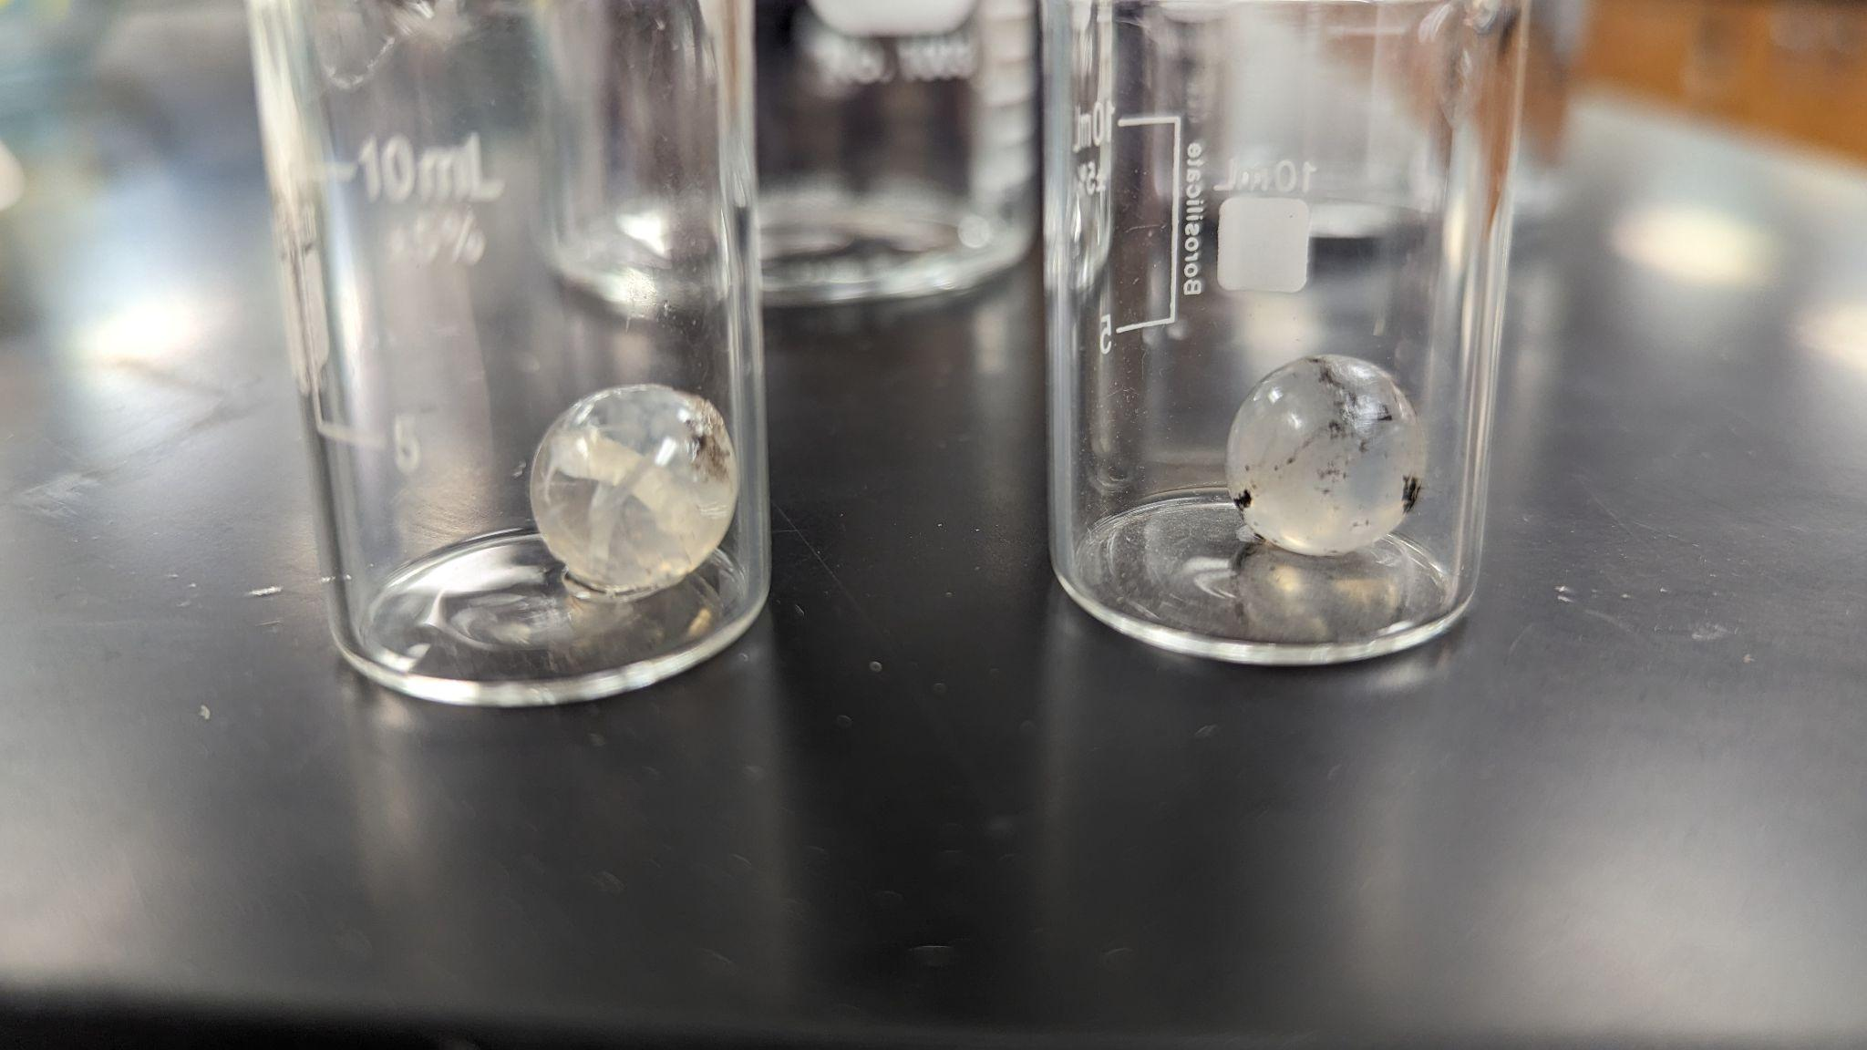

Figure 1. Lens cores?

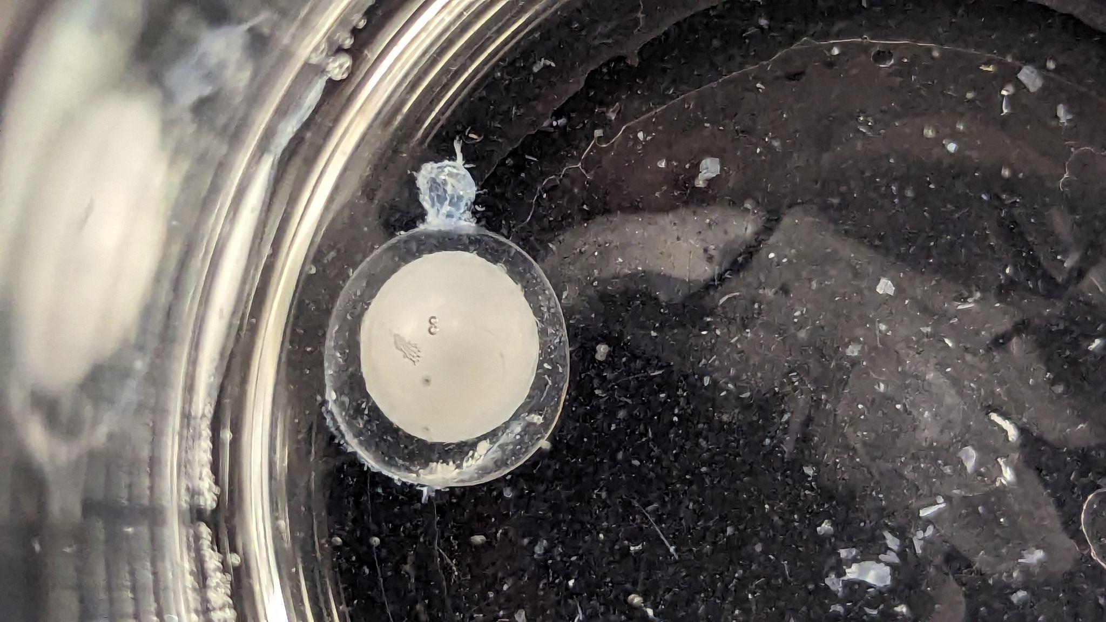

Figure 2. Notes from Dan: there are two distinct regions of the lens, and I believe these to be the cortical portion (transparent) and the nuclear region (opaque). I recognize this from when I worked with human lenses as well, where the freeze/thaw can sometimes affect the nuclear and cortical regions of the lens differently, as the cortical region seems to "bounce-back" from the trauma and appears better at regaining its optical transparency when compared to the nuclear region. Another thing you can see is the success we had unpeeling the lens as layers (instead of having it break apart into chunks, ooze, etc). That little feather-looking thing is a layer peeling off, and you can see how cleanly and evenly the process has been working. This photo was taken after 2 decent-sized layers were already removed. The unpeeling process is really cool to watch- as you may see in the photo- these fibers are not visible within the lens until they peel away from the transparent whole of the lens. NOTE: opacity is not necessarily indicative of “good” or “bad” lenses.

Storage and transferring plan

* All frozen eyes currently at ABL/Juneau
* Ship in batches once funds are accessible and space allows. Very limited freezer space at ARC.
* Dan’s lab will process samples, store tubes in fridge at home until transfer to LLNL
  + Any supply needs?

How should samples be sub-sampled?

* Size
* Sex
* Region

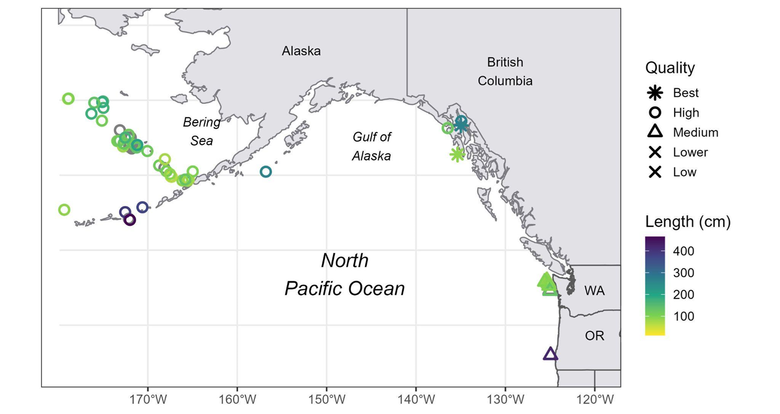

Timeline to start running samples at LLNL? Should they be in a big batch, or small batches? What is the optimal number of samples to run at LLNL at a given time?

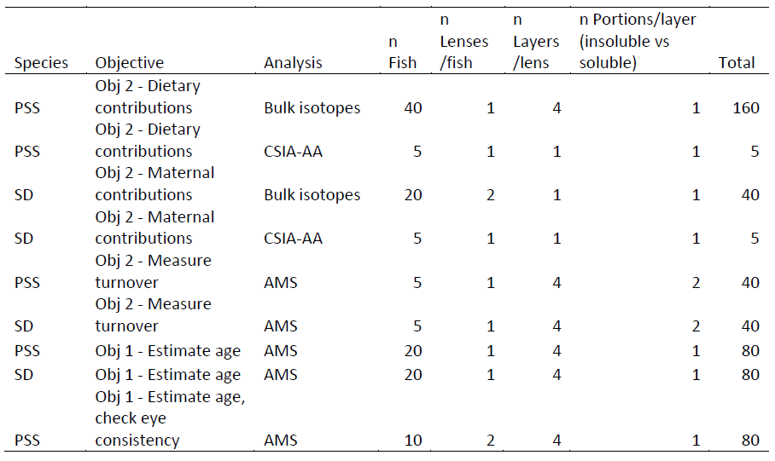

## DRAFT roles/expectations/manuscripts

Obj 1. Evaluate 14C values in PSS and SD eye lens cores (earliest material) and outer layers (recent material) as an indicator of age. Assess the eye lens 14C chronology by comparison with validated ages of SD. Estimate plausible ranges of age-at-length, age-at-maturity, and lifespan of PSS.

1. Do the reference 14C samples from SD eye lenses portray an accurate bomb 14C timeline?
2. Do 14C levels in eye lens cores from PSS of different sizes show evidence of formation during the prebomb, bomb-rise, or post-peak periods as an indication of birth year or temporal constraints on the age of each specimen?
3. Can accurate estimates of age be derived for PSS from eye lens 14C values and does sequential sampling work as a proxy for 14C uptake through ontogeny?

Obj 2. Investigate sources of potential variation in isotopic values (13C, 14C, and 15N) of shark eye lens protein. These include sample quality (e.g., freezing/thawing altering the structure of the eye lens), the potential for protein turnover in eye lenses, dietary and maternal contributions, and the effects of habitat, depth, and region on isotope uptake.

1. Does carbon turnover occur in shark eye lenses, and if so, would it affect the interpretation of 14C values as a temporal reference and require a correction factor? (lead - Dan)
2. What are the sources of carbon in the shark eye lens? (lead - Taylor)

Obj 3. Estimate age-related life history parameters (and associated uncertainty) used in stock assessments and test more robust stock assessment approaches. (lead - Cindy)